Tools for Enforcing Secure Code
Daniel M Beck
UMGC – SDEV-360
July 27, 2020

Tools for Enforcing Secure Code

Introduction - What is Security Testing?
With the greater need for secure software came tools that were developed to assist in the process of identifying vulnerabilities in code development. Robert Secord and Robert Schiela state, as one of the top 10 secure code practices, that businesses should “develop and/or apply a secure coding standard for your target development language and platform” (Seacord, R. & Schiela, R., 2018) to help reinforce the security of the developed code. For companies that use the Python development language, Bandit has been found to be a beneficial tool.

Bandit
Bandit scans developers code for any known vulnerabilities and then provides explicit feedback about what has been found, the severity of the problem, and how confident it is in its discovery. Bandit is “great for catching issues like insecure configurations, known insecure module usage, hard-codes credentials, asserts, and much more” (Scott, 2020). A few reasons that Bandit is so popular, is that it is a free, open-source software that is configurable, and fast. Figure 1 shows how to install Bandit if the developer is running Python on their machine.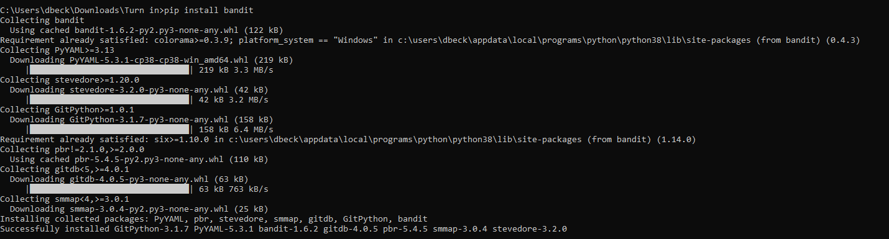
Figure 1, Installing Bandit with the command prompt
Figure 2 shows the list of tests that Bandit runs to discover vulnerabilities. These tests are created from known; common vulnerabilities that have been encountered.
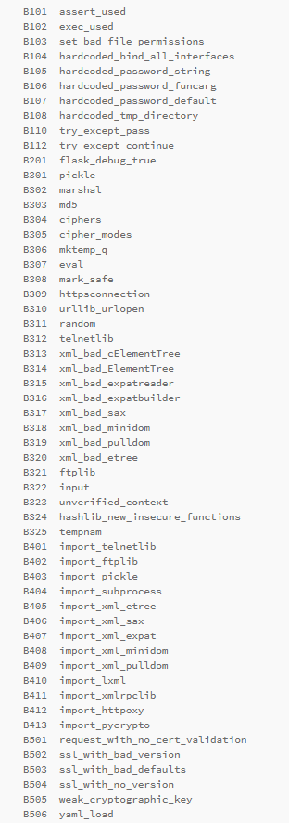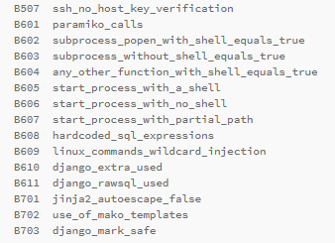
Figure 2, Security tests that are executed when a file is run through bandit. Retrieved from pypi.org/project/bandit
The only disadvantage to using Bandit would be that it does not catch every vulnerability, so it would be good practice to use multiple tools to test the software.

Use of Bandit with Python Program that Runs a Simple Website with Flask
Another part of the simplicity of Bandit is how to run it. With the correct directory selected in the command prompt, typing “bandit -r filename.py” runs the selected code through Bandit. In a previous course, I wrote a project that runs a simple website, using Flask, that navigates through four pages. Figure 3 shows that running that file through Bandit caught an issue with test B201:flask_debug_true. This error occurred because as I was testing the website, it was easier to leave the code in debug mode so that I did not have to refresh the browser for every change. This would be an easy oversight when completing the code.
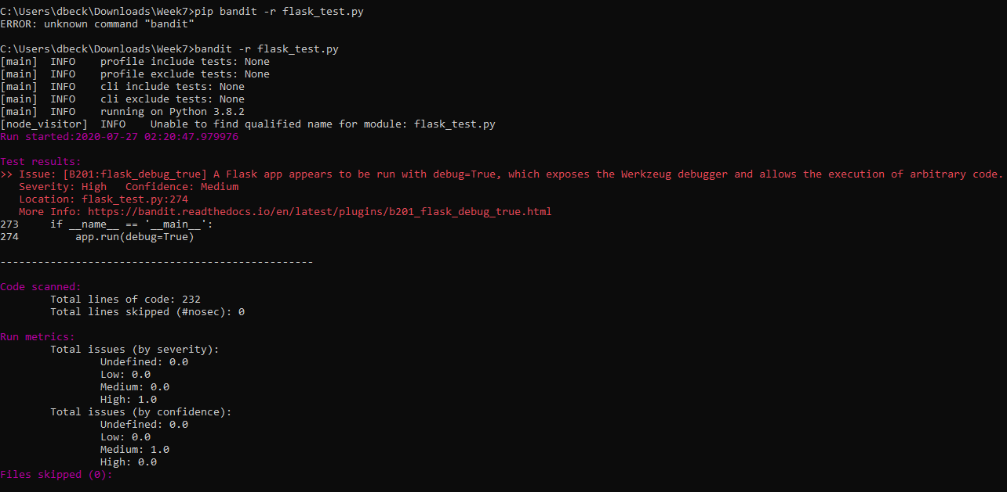
Figure 3, Running Bandit on code that runs a simple website

Use of Bandit with Python Program that Checks Password Complexity
Another project from a previous course that I ran through the Bandit tool was a program that asks the user for a password, then checks that the password is complex enough and that it did not match any common passwords. Figure 4 shows that running the password program through Bandit caught the issue with test B201:flask_debug_true again. Using this tool while attending this course seem like it would have been useful as it looks like a habit was being created of not setting debug mode to false before completing the project.
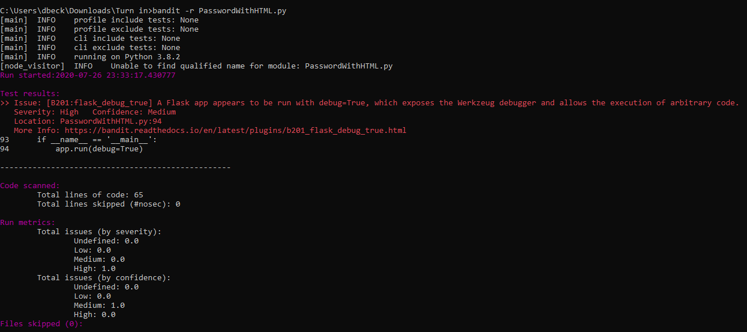
Figure 4, Running Bandit on code that checks complexity of password

Conclusion
Bandit, and other tools like it, are growing exceedingly important to utilize since they “uncover vulnerabilities of the system and determines that the data and resources of the system are protected from possible intruders” (Software Testing: Security Testing, 2019). This tools also ensure that the software system and application are free from any threats or risks that can cause a loss of data or leak. Using this tool with any Python code focuses on finding all possible loopholes and weaknesses of the code which might result into the loss of information or the corruption of programs.

References
Bandit. (2019, July 1). Retrieved July 28, 2020, from https://pypi.org/project/bandit/
Seacord, R. & Schiela, R. (2018, May 02). Top 10 Secure Coding Practices. Retrieved July 26, 2020, from https://wiki.sei.cmu.edu/confluence/display/seccode/Top+10+Secure+Coding+Practices
Scott, A. (2020, February 25). Top Python Tools for Developing Secure, Quality Code. Retrieved July 27, 2020, from https://levelup.gitconnected.com/top-python-tools-for-developing-secure-quality-code-4b3f5ec1e2de
Software Testing: Security Testing. (2019, May 10). Retrieved July 28, 2020, from https://www.geeksforgeeks.org/software-testing-security-testing/

